FITNESS TRACKER
@CREATIVITY THINK (9483175986/7019689991)

ABSTRACT:
The Fitness Tracker is a web-based platform designed to help users monitor and manage their health and wellness activities, including exercise, diet, and progress tracking. Users can log activities, record calorie intake, set fitness goals, and visualize progress through interactive graphs. Administrators manage the exercise and food database, oversee user statistics, configure entries, send newsletters, and generate analytical insights through dashboards. Developed with Django and Django REST Framework for backend operations and React with Recharts for frontend data visualization, the system ensures personalized, data-driven, and efficient fitness tracking..

INTRODUCTION OF THE PROJECT:
Maintaining a healthy lifestyle requires consistent monitoring of physical activities, dietary habits, and progress. Many individuals and fitness centers struggle to track and analyze these aspects efficiently. The Fitness Tracker addresses these challenges by providing a centralized digital platform for recording activities, setting goals, monitoring progress, and analyzing trends. Users benefit from interactive dashboards, visual progress graphs, notifications, and exportable reports, while administrators gain insights to manage and guide users effectively..

PROJECT OBJECTIVES:

• Provide a web-based platform to log activities, diet, and calories
• Enable users to set personal fitness goals and monitor progress
• Display progress through interactive charts and analytics
• Send reminders and notifications for activities and goals
• Allow administrators to manage the exercise and food database
• Track user statistics and configure entries through dashboards
• Provide newsletters and updates to users
• Ensure scalable and secure backend with structured APIs

PROBLEM OF THE STATEMENT:
Individuals and fitness centers often lack an organized system to monitor health and wellness efficiently. Manual tracking or disparate apps fail to consolidate exercise, diet, goal-setting, and analytics in a single platform. Users find it difficult to monitor progress visually, while administrators struggle to manage user data, maintain databases, and generate actionable insights. The Fitness Tracker solves these challenges by providing a centralized, interactive, and analytics-enabled system for fitness monitoring and guidance..

MOTIVATION OF THE PROJECT:
• To facilitate systematic monitoring of health and fitness activities
• To help users set, track, and achieve personal goals
• To provide visual insights and interactive progress reports
• To allow administrators to manage exercise/food databases efficiently
• To send reminders, notifications, and newsletters for better engagement
• To support decision-making through analytical dashboards
• To deliver a scalable and user-friendly fitness management solution

BLOCK DAIGRAM OF PROJECT:

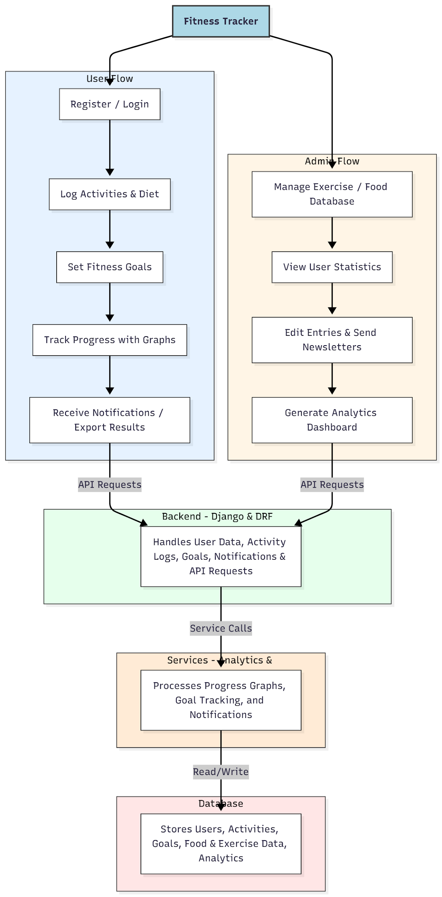

WORKING OF THE PROJECT:
Users register and log into the system, then record their daily activities, diet intake, and calories. They can set personal fitness goals and track progress using interactive graphs and dashboard analytics. Notifications and reminders alert users about milestones, activities, and goals. Administrators manage the exercise and food database, edit entries, review user statistics, and send newsletters. The backend handles all API requests, stores user and activity data in the database, and processes analytics and notifications, ensuring reliable and scalable operation..

SOFTWARE REQUIREMENT:
- Backend:
  - Python 3.x
  - Django
  - Django REST Framework
  - SQLite/PostgreSQL
- Frontend:
  - Node.js and npm
  - React.js
  - Axios
- Development Tools:
  - Visual Studio Code
  - Postman (for testing APIs)
  - Git/GitHub (for version control)
- Server/Deployment (Optional):
  - Gunicorn, Nginx, or Heroku/AWS for hosting

ADVANTAGES OF THE PROJECT:

• Centralized fitness tracking and goal management
• Visual progress through graphs and charts
• Notifications and reminders for activities and goals
• Admin dashboard for database management and analytics
• Exportable results for user records
• Supports both individual and organizational fitness management
• Enhances user engagement and accountability
• Scalable and secure platform

APPLICATIONS OF THE PROJECT:
• Fitness centers and gyms
• Individual health and wellness tracking
• Corporate wellness programs
• Personal trainers and nutrition coaches
• Educational institutions for health monitoring
• Health and lifestyle research projects

REFERENCES:

- Django REST Framework Documentation — Django Software Foundation. Django Documentation. Available: https://docs.djangoproject.com/
- Django REST Framework. DRF Documentation. Available: https://www.django-rest-framework.org/
- React. React Official Documentation. Available: https://reactjs.org/docs/getting-started.html
- Redux. Redux Documentation. Available: https://redux.js.org/introduction/getting-started
- PostgreSQL Global Development Group. PostgreSQL Documentation. Available: https://www.postgresql.org/docs/
- MySQL. MySQL Reference Manual. Available: https://dev.mysql.com/doc/
- Git. Git Documentation. Available: https://git-scm.com/doc
- Node.js. Node.js Documentation. Available: https://nodejs.org/en/docs/
- Axios. Axios Documentation. Available: https://axios-http.com/docs/intro
- Socket.io Documentation – https://socket.io/docs/

